Assignment 5

1. Program Output

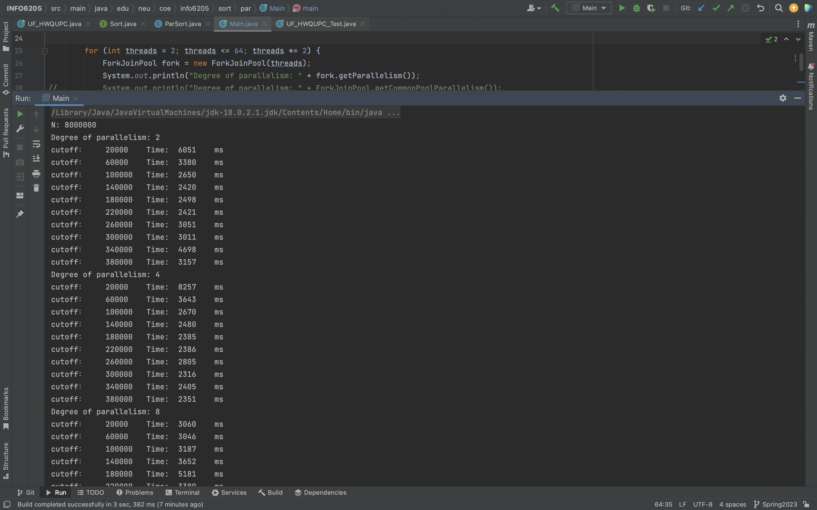

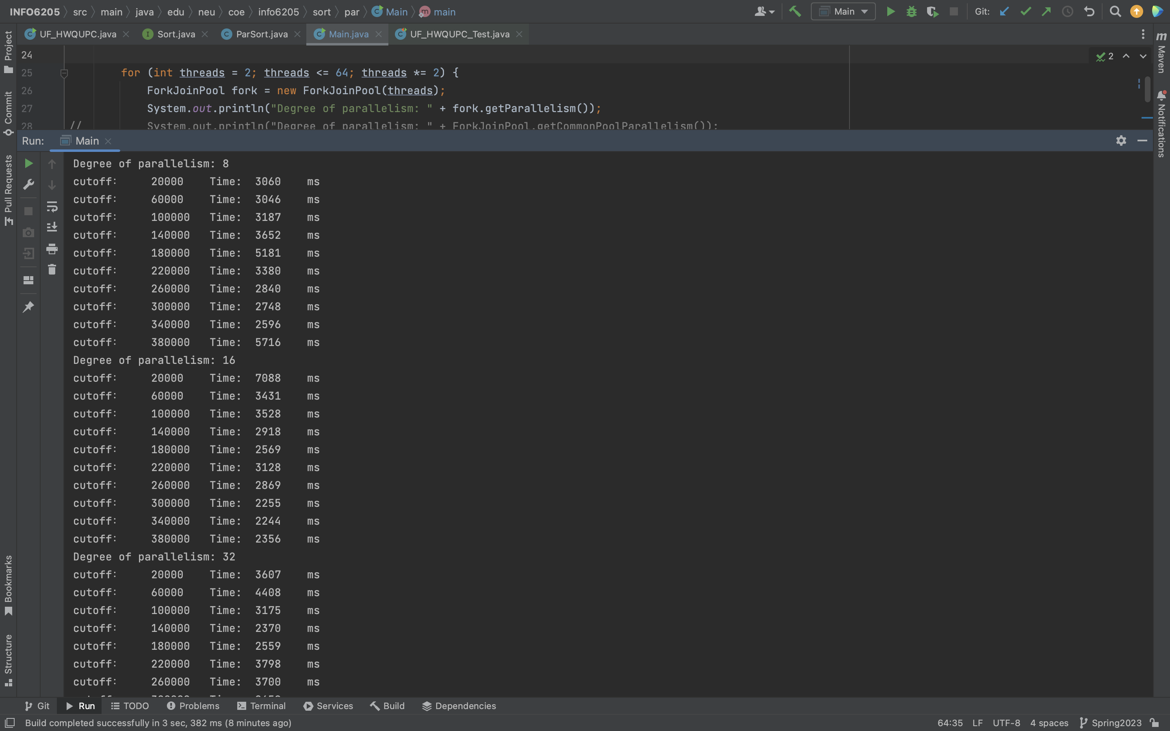

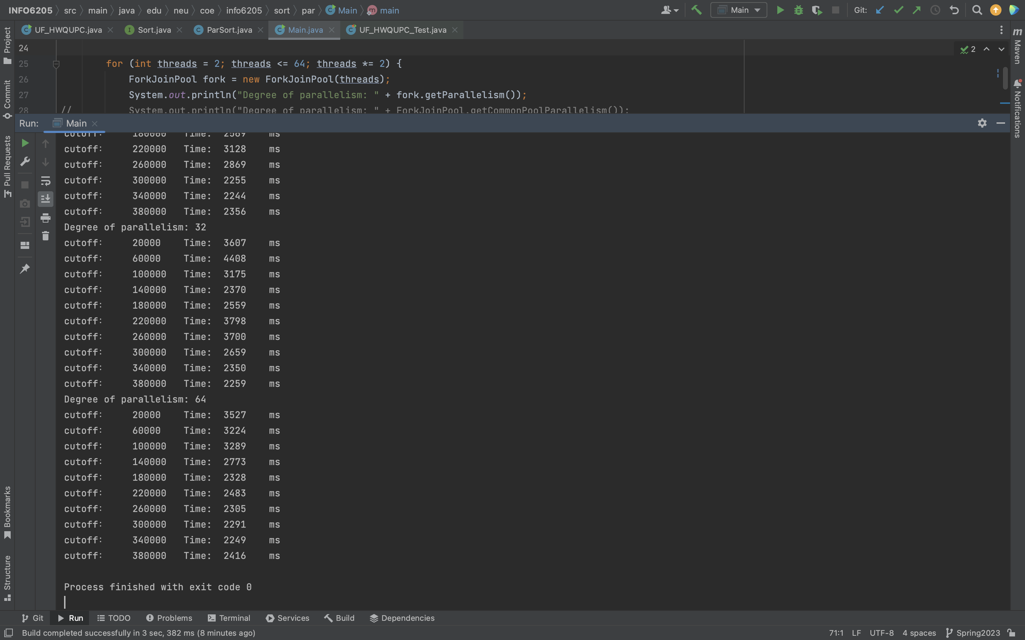

**Observations:**

Array size: 2000000

|  |  |  |  |  |  |  |
| --- | --- | --- | --- | --- | --- | --- |
| Cut off | Time (ms) 2 Threads | Time (ms) 4 Threads | Time (ms) 8 Threads | Time (ms) 16 Threads | Time (ms) 32 Threads | Time (ms) 64 Threads |
| 20000 | 1092 | 1179 | 1562 | 1203 | 795 | 1636 |
| 60000 | 655 | 836 | 1590 | 1205 | 618 | 966 |
| 100000 | 740 | 563 | 1368 | 897 | 549 | 585 |
| 140000 | 690 | 596 | 1448 | 589 | 567 | 566 |
| 180000 | 668 | 598 | 563 | 555 | 608 | 587 |
| 220000 | 660 | 746 | 628 | 557 | 607 | 565 |
| 260000 | 793 | 790 | 605 | 560 | 650 | 578 |
| 300000 | 785 | 720 | 619 | 582 | 753 | 662 |
| 340000 | 798 | 687 | 724 | 730 | 676 | 992 |
| 380000 | 1000 | 816 | 946 | 765 | 952 | 747 |

Array size: 4000000

|  |  |  |  |  |  |  |
| --- | --- | --- | --- | --- | --- | --- |
| Cut off | Time (ms) 2 Threads | Time (ms) 4 Threads | Time (ms) 8 Threads | Time (ms) 16 Threads | Time (ms) 32 Threads | Time (ms) 64 Threads |
| 20000 | 1968 | 1641 | 2050 | 1396 | 1498 | 1436 |
| 60000 | 1966 | 1356 | 3941 | 1184 | 1185 | 1186 |
| 100000 | 1340 | 1191 | 1128 | 1126 | 1149 | 1193 |
| 140000 | 1265 | 1157 | 1093 | 1127 | 1129 | 1189 |
| 180000 | 1445 | 1157 | 1168 | 1085 | 1110 | 1245 |
| 220000 | 1264 | 1151 | 1127 | 1181 | 1099 | 1225 |
| 260000 | 1575 | 1347 | 1228 | 1109 | 1109 | 1138 |
| 300000 | 2707 | 2320 | 1821 | 1098 | 1110 | 1128 |
| 340000 | 2336 | 2037 | 2307 | 1142 | 1093 | 1159 |
| 380000 | 1563 | 1654 | 1112 | 1190 | 1111 | 1469 |

Array size: 8000000

|  |  |  |  |  |  |  |
| --- | --- | --- | --- | --- | --- | --- |
| Cut off | Time (ms) 2 Threads | Time (ms) 4 Threads | Time (ms) 8 Threads | Time (ms) 16 Threads | Time (ms) 32 Threads | Time (ms) 64 Threads |
| 20000 | 6051 | 8257 | 3060 | 7088 | 3607 | 3527 |
| 60000 | 3380 | 3643 | 3046 | 3431 | 4408 | 3224 |
| 100000 | 2650 | 2670 | 3187 | 3528 | 3175 | 3289 |
| 140000 | 2420 | 2480 | 3652 | 2918 | 2370 | 2773 |
| 180000 | 2498 | 2385 | 5181 | 2569 | 2559 | 2328 |
| 220000 | 2421 | 2386 | 3380 | 3128 | 3798 | 2483 |
| 260000 | 3051 | 2805 | 2840 | 2869 | 3700 | 2305 |
| 300000 | 3011 | 2316 | 2748 | 2255 | 2659 | 2291 |
| 340000 | 4698 | 2405 | 2596 | 2244 | 2350 | 2249 |
| 380000 | 3157 | 2351 | 5716 | 2356 | 2259 | 2416 |

1. **Conclusions:**
2. Based on the all the graphs, when the cut off is 2%-3% of input size array, the running time is faster.
3. Based on all graphs number of threads = 64 takes less time than other threads.
4. The time remains similar and no significant difference when the array size increase.

Hence as per the analysis, the ideal cut off value is 2% of the input size array and ideal thread count is 64.